SQL Backup DB

🌟 Definition
# Source: AI Source: Provided by: [Data Path: Persons Table -> ID Column: 1, Name_En Column: Motasem Essam] -> From: [ChatGPT] on [6/11/2026]
A SQL Database Backup is the process of creating a copy of a database so that it can be restored if the original database is lost, damaged, or corrupted.
Backups protect data from:
- Hardware failures
- Software errors
- Accidental deletion
- Cyberattacks (such as ransomware)
- Natural disasters

🎯 Purpose
# Source: AI Source: Provided by: [Data Path: Persons Table -> ID Column: 1, Name_En Column: Motasem Essam] -> From: [ChatGPT] on [6/11/2026]
Database backups are used to:
- Recover lost data
- Restore databases after failures
- Protect against accidental changes
- Migrate databases to another server
- Create copies for testing and development

🧠 Simple Example
# Source: AI Source: Provided by: [Data Path: Persons Table -> ID Column: 1, Name_En Column: Motasem Essam] -> From: [ChatGPT] on [6/11/2026]
Imagine your database contains customer information.
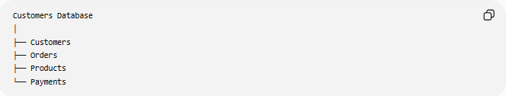
Customers Database
│
├── Customers
├── Orders
├── Products
└── Payments
Creating a backup produces:
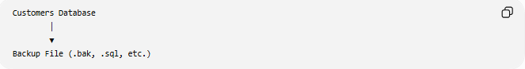
Customers Database
│
▼
Backup File (.bak, .sql, etc.)
If the database is lost, you can restore it from the backup.

📝 Common Backup Commands
# Source: AI Source: Provided by: [Data Path: Persons Table -> ID Column: 1, Name_En Column: Motasem Essam] -> From: [ChatGPT] on [6/11/2026]
Backup commands differ depending on the database system.
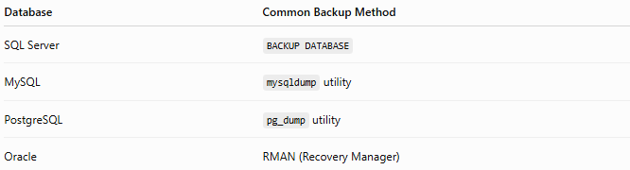
Database | Common Backup Method
SQL Server | BACKUP DATABASE
MySQL | mysqldump utility
PostgreSQL | pg_dump utility
Oracle | RMAN (Recovery Manager)

1️⃣ SQL Server Backup
# Source: AI Source: Provided by: [Data Path: Persons Table -> ID Column: 1, Name_En Column: Motasem Essam] -> From: [ChatGPT] on [6/11/2026]
Create a full database backup.
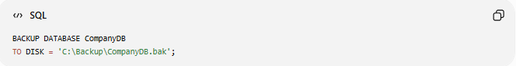
BACKUP DATABASE CompanyDB
TO DISK = 'C:\Backup\CompanyDB.bak';
This creates a backup file named:
CompanyDB.bak

2️⃣ SQL Server Backup with Options
# Source: AI Source: Provided by: [Data Path: Persons Table -> ID Column: 1, Name_En Column: Motasem Essam] -> From: [ChatGPT] on [6/11/2026]
Overwrite an existing backup file.
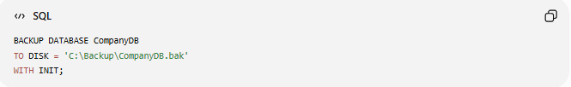
BACKUP DATABASE CompanyDB
TO DISK = 'C:\Backup\CompanyDB.bak'
WITH INIT;

3️⃣ SQL Server Restore
# Source: AI Source: Provided by: [Data Path: Persons Table -> ID Column: 1, Name_En Column: Motasem Essam] -> From: [ChatGPT] on [6/11/2026]
Restore a database from a backup.
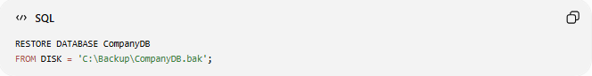
RESTORE DATABASE CompanyDB
FROM DISK = 'C:\Backup\CompanyDB.bak';

4️⃣ MySQL Backup
# Source: AI Source: Provided by: [Data Path: Persons Table -> ID Column: 1, Name_En Column: Motasem Essam] -> From: [ChatGPT] on [6/11/2026]
MySQL uses the mysqldump command-line utility.
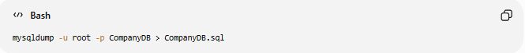
mysqldump -u root -p CompanyDB > CompanyDB.sql
This exports the database into a SQL script.

5️⃣ MySQL Restore
# Source: AI Source: Provided by: [Data Path: Persons Table -> ID Column: 1, Name_En Column: Motasem Essam] -> From: [ChatGPT] on [6/11/2026]

mysql -u root -p CompanyDB < CompanyDB.sql

6️⃣ PostgreSQL Backup
# Source: AI Source: Provided by: [Data Path: Persons Table -> ID Column: 1, Name_En Column: Motasem Essam] -> From: [ChatGPT] on [6/11/2026]
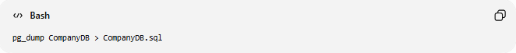
pg_dump CompanyDB > CompanyDB.sql

7️⃣ PostgreSQL Restore
# Source: AI Source: Provided by: [Data Path: Persons Table -> ID Column: 1, Name_En Column: Motasem Essam] -> From: [ChatGPT] on [6/11/2026]
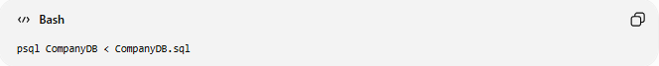
psql CompanyDB < CompanyDB.sql

📊 Types of Database Backups
# Source: AI Source: Provided by: [Data Path: Persons Table -> ID Column: 1, Name_En Column: Motasem Essam] -> From: [ChatGPT] on [6/11/2026]
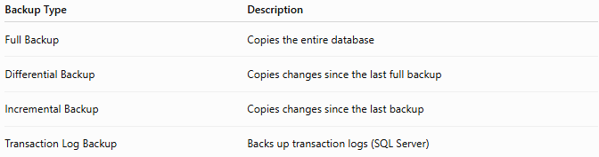
Backup Type | Description
Full Backup | Copies the entire database
Differential Backup | Copies changes since the last full backup
Incremental Backup | Copies changes since the last backup
Transaction Log Backup | Backs up transaction logs (SQL Server)

📚 Full Backup Example
# Source: AI Source: Provided by: [Data Path: Persons Table -> ID Column: 1, Name_En Column: Motasem Essam] -> From: [ChatGPT] on [6/11/2026]
Monday
Full Backup
Everything is copied.

📚 Differential Backup
# Source: AI Source: Provided by: [Data Path: Persons Table -> ID Column: 1, Name_En Column: Motasem Essam] -> From: [ChatGPT] on [6/11/2026]
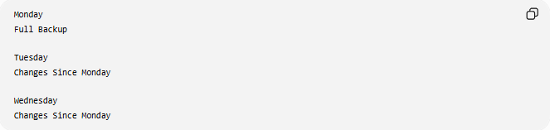
Monday
Full Backup

Tuesday
Changes Since Monday

Wednesday
Changes Since Monday

📚 Incremental Backup
# Source: AI Source: Provided by: [Data Path: Persons Table -> ID Column: 1, Name_En Column: Motasem Essam] -> From: [ChatGPT] on [6/11/2026]
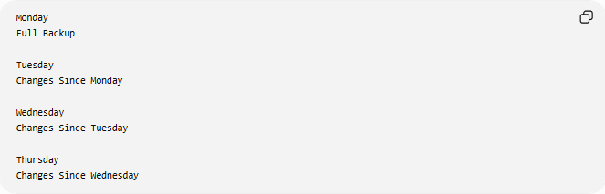
Monday
Full Backup

Tuesday
Changes Since Monday

Wednesday
Changes Since Tuesday

Thursday
Changes Since Wednesday

🛠️ Complete Test Example (SQL Server)

Create Database
# Source: AI Source: Provided by: [Data Path: Persons Table -> ID Column: 1, Name_En Column: Motasem Essam] -> From: [ChatGPT] on [6/11/2026]
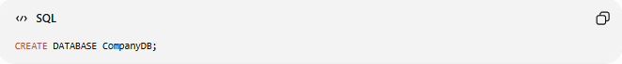
CREATE DATABASE CompanyDB;

Backup Database
# Source: AI Source: Provided by: [Data Path: Persons Table -> ID Column: 1, Name_En Column: Motasem Essam] -> From: [ChatGPT] on [6/11/2026]
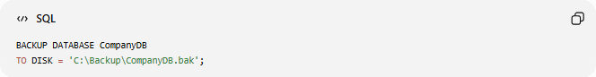
BACKUP DATABASE CompanyDB
TO DISK = 'C:\Backup\CompanyDB.bak';

Restore Database
# Source: AI Source: Provided by: [Data Path: Persons Table -> ID Column: 1, Name_En Column: Motasem Essam] -> From: [ChatGPT] on [6/11/2026]
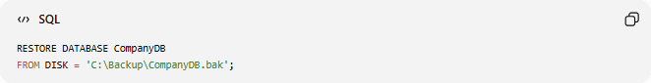
RESTORE DATABASE CompanyDB
FROM DISK = 'C:\Backup\CompanyDB.bak';

📊 Backup vs Restore
# Source: AI Source: Provided by: [Data Path: Persons Table -> ID Column: 1, Name_En Column: Motasem Essam] -> From: [ChatGPT] on [6/11/2026]
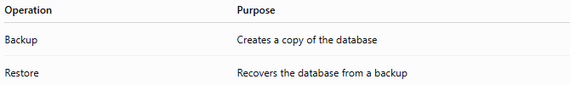
Operation | Purpose
Backup | Creates a copy of the database
Restore | Recovers the database from a backup

⚠️ Important Notes
# Source: AI Source: Provided by: [Data Path: Persons Table -> ID Column: 1, Name_En Column: Motasem Essam] -> From: [ChatGPT] on [6/11/2026]
- Always store backups in a different location from the production database.
- Test backups regularly by performing a restore.
- Schedule automatic backups for production systems.
- Keep multiple backup versions.
- Protect backup files because they may contain sensitive data.

🌍 Database Backup Tools
# Source: AI Source: Provided by: [Data Path: Persons Table -> ID Column: 1, Name_En Column: Motasem Essam] -> From: [ChatGPT] on [6/11/2026]
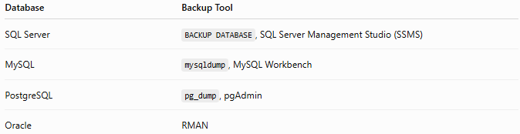
Database | Backup Tool
SQL Server | BACKUP DATABASE, SQL Server Management Studio (SSMS)
MySQL | mysqldump, MySQL Workbench
PostgreSQL | pg_dump, pgAdmin
Oracle | RMAN

🔢 Backup Workflow
# Source: AI Source: Provided by: [Data Path: Persons Table -> ID Column: 1, Name_En Column: Motasem Essam] -> From: [ChatGPT] on [6/11/2026]
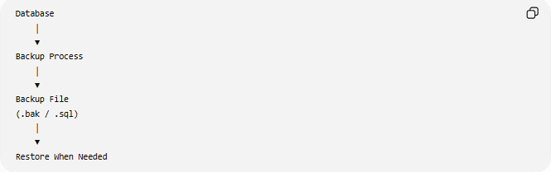
Database
│
▼
Backup Process
│
▼
Backup File
(.bak / .sql)
│
▼
Restore When Needed

🧠 Simple Analogy
# Source: AI Source: Provided by: [Data Path: Persons Table -> ID Column: 1, Name_En Column: Motasem Essam] -> From: [ChatGPT] on [6/11/2026]
Imagine writing an important document on your computer.
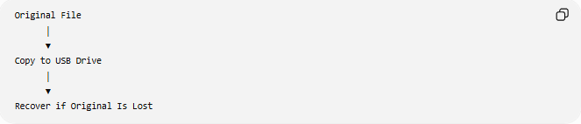
Original File
│
▼
Copy to USB Drive
│
▼
Recover if Original Is Lost
A database backup works the same way—it creates a copy of the database so you can restore it if something goes wrong.

🧭 Summary
# Source: AI Source: Provided by: [Data Path: Persons Table -> ID Column: 1, Name_En Column: Motasem Essam] -> From: [ChatGPT] on [6/11/2026]
A SQL Database Backup is a copy of a database created to protect data from loss, corruption, or system failures. Backups are an essential part of database administration and disaster recovery. Different DBMSs use different tools and commands—such as BACKUP DATABASE in SQL Server, mysqldump in MySQL, and pg_dump in PostgreSQL—to create and restore database backups.

